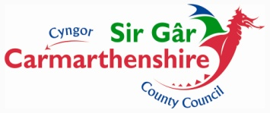
Carmarthenshire County Council

Request for Extension to Contract

Request for exception and waiver to the requirements of competition, in accordance with Section Condition 5.4.1.1 **amend accordingly** of Contract Procedure Rules, for **Enter Contract Title here**.
Recommendations Required:
That when the Council’s current contract for the **Enter Contract Title here** expires on **Enter expiry date**, the Council will:-

Extend the contract for the maximum duration of x months as stated in the original tender documents.

Reasons:

**Please list the reasons why the contract should be extended; this might include the fact the lead officer and evaluation panel believe in is in the authority’s interests to do so, performance of the contract has exceeded/met expectations, delivery/performance of goods/service has been of a very high standard, savings achieved, Prices negotiated for extension period, cost advantages/savings to be made by not having to carry out another procurement exercise for x months, waiting to join a collaborative arrangement etc**

Other options available have been explored and their pros and cons are outlined here:

Recommendation summary:

Approval to Proceed: | Signed | Date
Lead Officer

Head of Service

Please note that the Corporate Procurement Unit must be informed of this extension in order to amend the Council’s Contract Register. Failure to notify will result in this spend appearing as off contract for Audit purposes.

