OneDrive
OneDrive is a Microsoft cloud storage service that lets you store your personal files in one place, share them with others, and get to them from any device connected to the Internet.
OneDrive will replace your U Drive as the storage area for personal work related files. One Drive has many benefits including:
- Access files from any corporate device e.g. PC, work phone or work tablet. Continue what you started, wherever you happen to be. Any changes you make will be updated on all of your devices

- Share and Collaborate. You can share files, folders and photos with colleagues. No more large email attachments – just send a link.

You should already have a OneDrive icon on your desktop and in File Explorer - if you do not have one, please log a self-service call with the IT Helpdesk - http://itselfservice.
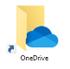
Desktop Icon | File Explorer Location

Your OneDrive will look similar to your U Drive but with an added column – Status. This column tells you where the file or folder is stored and whether it is shared or not.
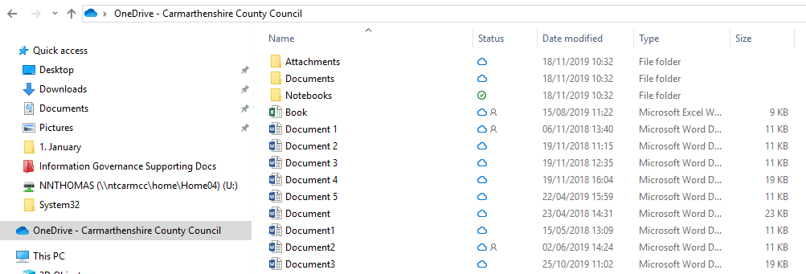

Icons

People icon next to a file or folder
If you see a "people" icon next to your OneDrive files or folders, this indicates the file or folder has been shared with other people.

Blue cloud icon
A blue cloud icon next to your OneDrive files or folders indicates that the file is only available online. Online-only files don’t take up space on your computer.
You can’t open online-only files when your device isn’t connected to the Internet.

Green tick icons
When you open an online-only file, it downloads to your device and becomes a locally available file. You can open a locally available file anytime, even without Internet access.
If you need more space, you can change the file back to online only. Just right-click the file and select “Free up space.”

Sharing
You can share files or folders that are stored in OneDrive by sending or posting a link to the file or folder to whomever you want. So, for example, if you want your manager to be able to see a folder, OneDrive creates a link for you that you can email to your manager. You and those that you have share a file with can simultaneously edit a document. To Share a file or folder:
- Right Click on a document or folder and a number of options will appear as below.

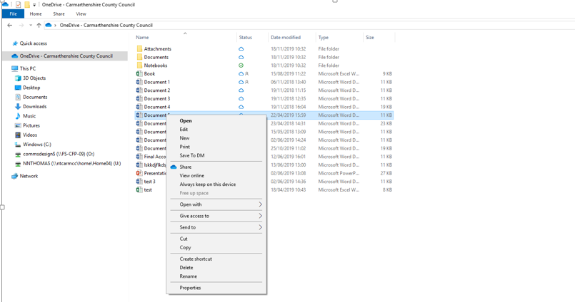

- Select Share and type in a user name, team mailbox or CFP security group. You can also add a message.
- 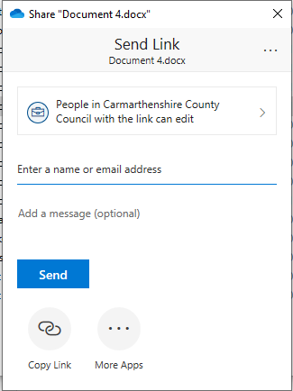

- Click Send
You will see that the shared file or folder will be marked with a icon.

Stop Sharing
To stop sharing a file or folder:
- Right click on a file or folder.
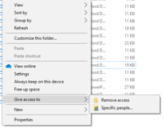
- Select Give access to and Remove access.

Creating and Saving New Documents
To create and save a document from your OneDrive:
- Open an existing document
- Click File from the Menu Bar and select New as you would usually do.
- Click File and Save As
- Select Computer and then the OneDrive folder

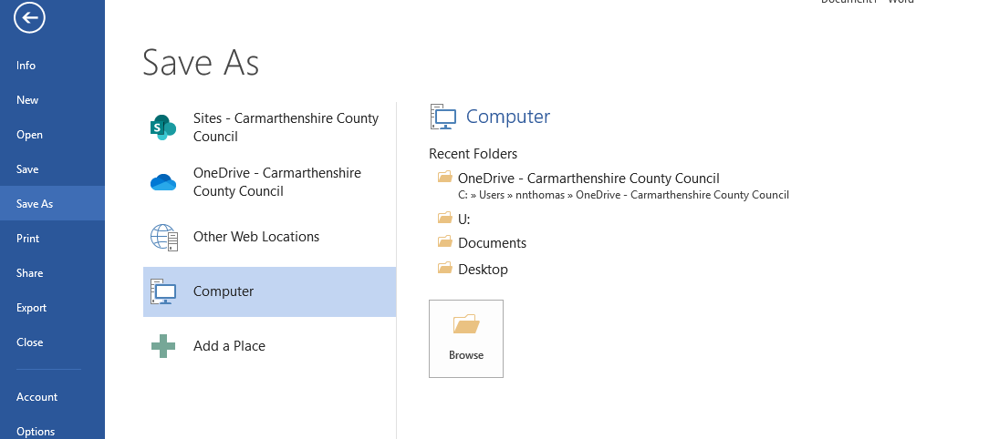

Recycle Bin
To restore deleted items:
When you delete files on OneDrive using File Explorer, they're moved to your computer's desktop Recycle Bin. Unless your Recycle Bin is overflowing, the files stay there for 30 days.
To open the Recycle Bin, double-click the Recycle Bin on the desktop.
- Right-click the item you want to restore, and select Restore.

Do
- Only keep files here which cannot usually be shared with anyone else. If they can or need to be shared (by one or more members of staff) move them to the Council File Plan with the appropriate access permissions
- You may want to keep documents here which are in draft format – once you have finished working on those documents you should then move them to a shared location and delete the old drafts
- Delete all non-work related files
Don’t
- Keep non-work related files in you OneDrive

