carmarthenshire.gov.uk

My VIEW system
Coronavirus – How to record Absence on

Contents

Hyperlink CTRL and left click on mouse over headings below to be taken to required section.

Coronavirus (self-isolation) (set up under other absence) - for use when an employee has been advised by NHS Direct or other NHS health professional to self-isolate but has no symptoms but is unable to work from home, e.g. home care, refuse loaders.

Coronavirus (self-isolation advised NHS 111) (set up under Sickness Infections inc Cold/Flu) where an employee does have symptoms but these are undiagnosed and has been advised by NHS Direct or an NHS health professional to self-isolate

Coronavirus (diagnosed) (set up under Sickness Infections inc Cold/Flu) where an employee does have symptoms and these have been diagnosed, and has been advised by NHS Direct or an NHS health professional to self-isolate.

Coronavirus (self-isolation) – for use when an employee has been advised by NHS Direct or other NHS health professional to self-isolate but has no symptoms but is unable to work from home, e.g. home care, refuse loaders

Select required team member in My People – Team Selector

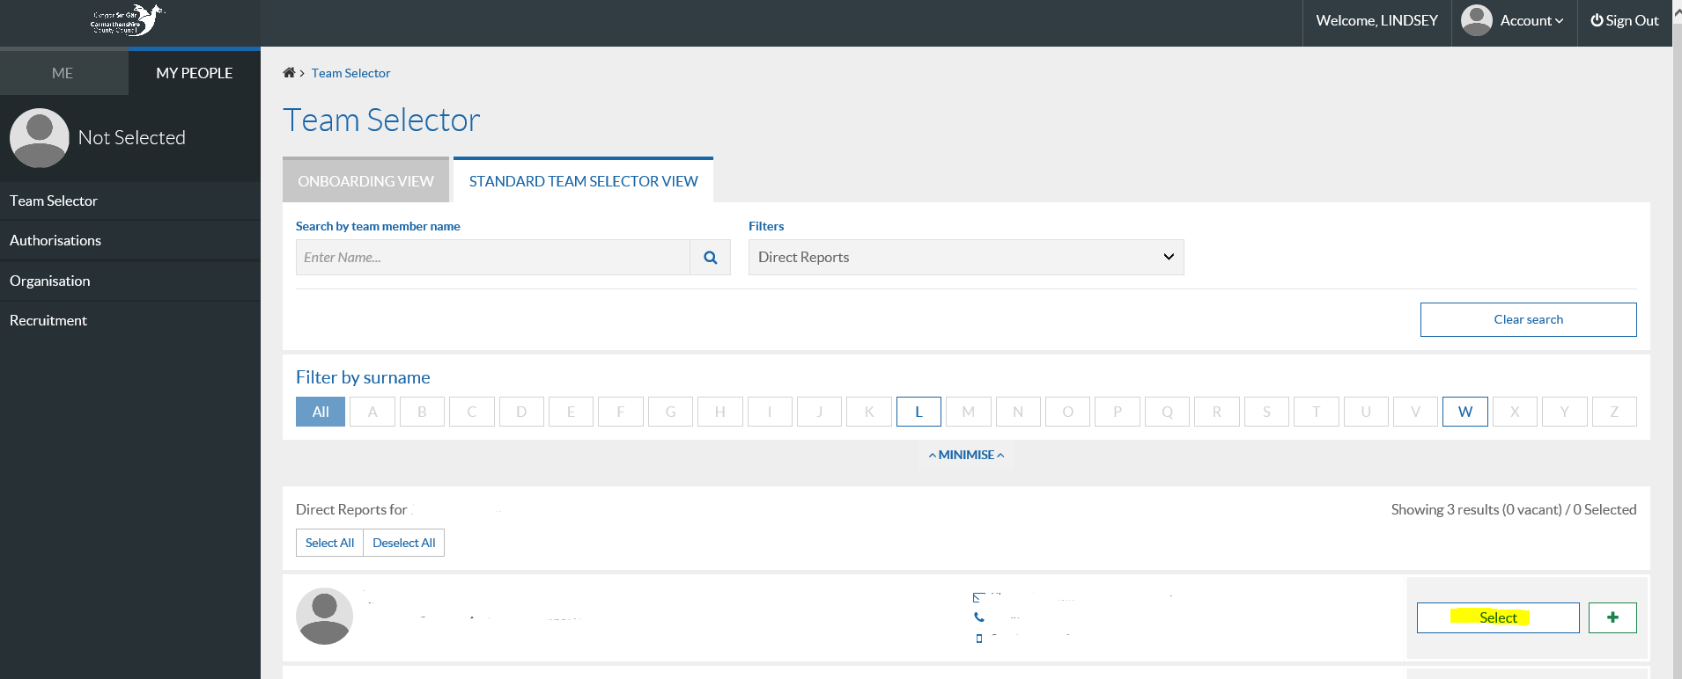

Select Other Absence on left had side of screen:

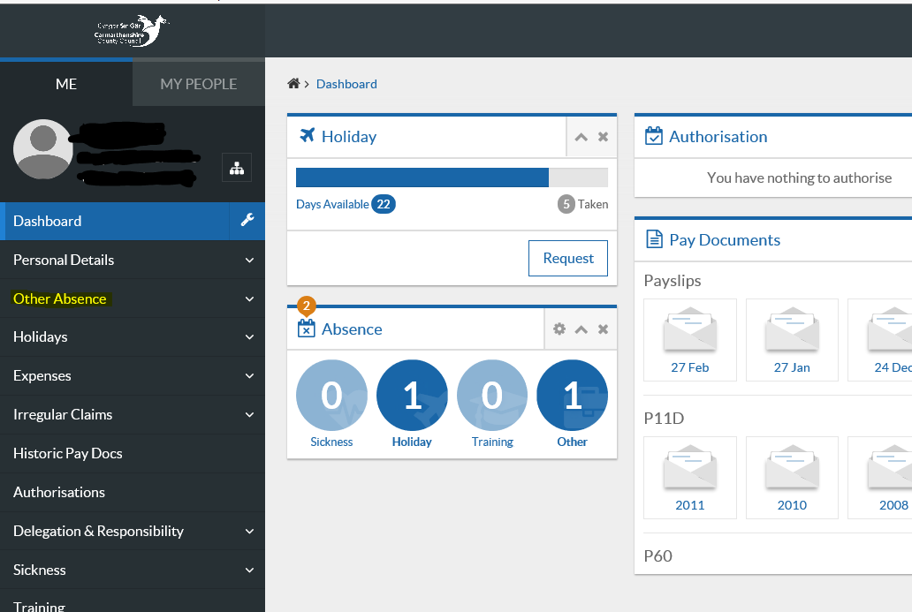

Select Other Absence Request:

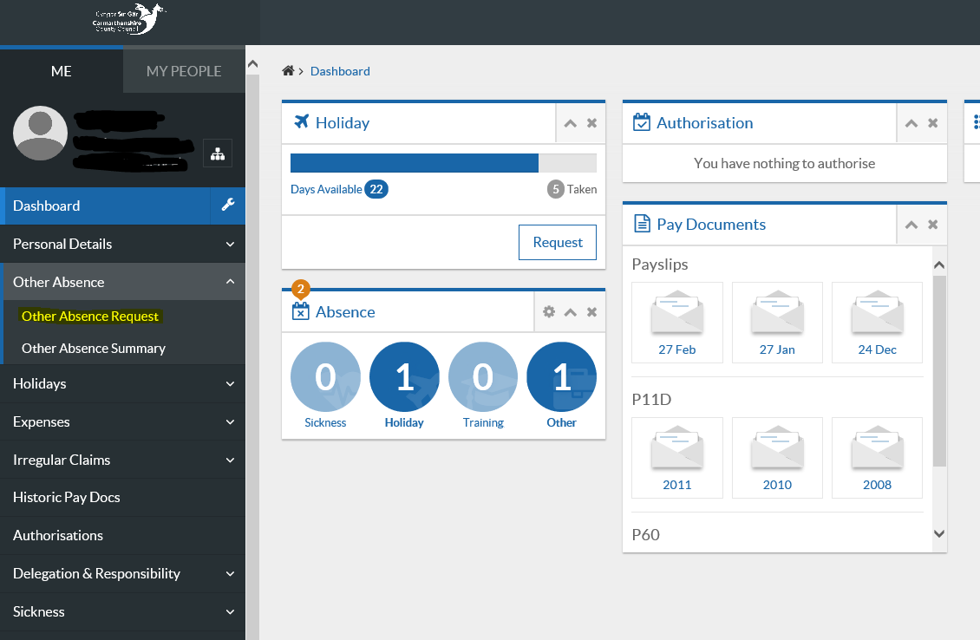

Select Absence in Absence Type, enter required dates, ie. the dates of self-isolation advised by NHS 111 or other NHS professional and click Next button:

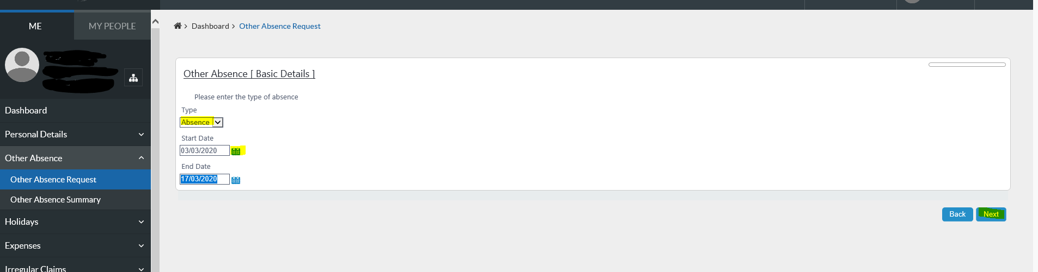

Please select PAID in Absence Type and select the reason Coronavirus (Self-isolation) as highlighted below and select the submit button.

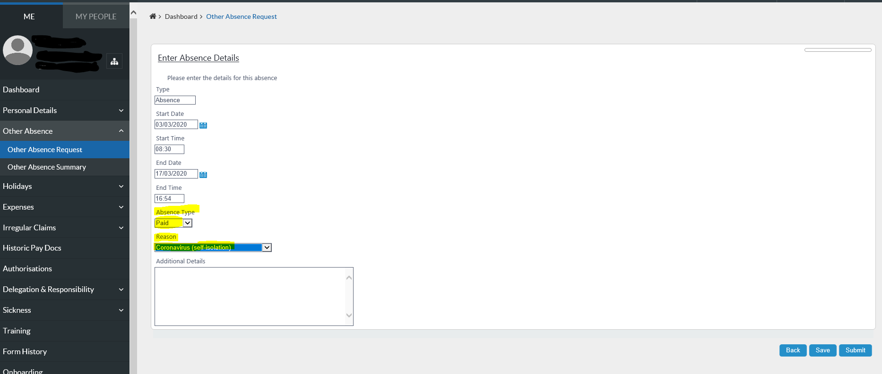

Coronavirus (self-isolation advised NHS 111) - set up under Sickness Infections inc Cold/Flu – where an employee does have symptoms, but these are undiagnosed and has been advised by NHS Direct or an NHS health professional to self-isolate

Go into Sickness Notifications:

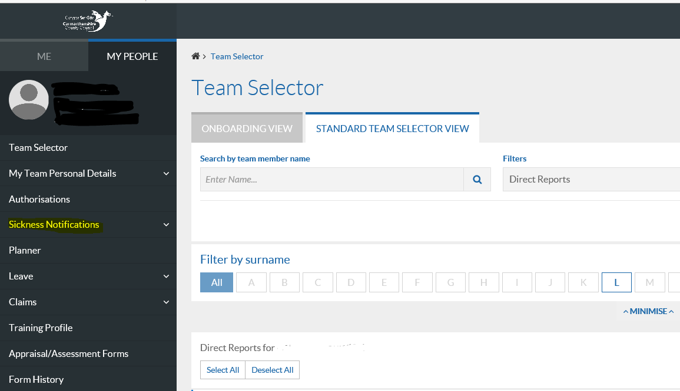

Select Notify Sickness:

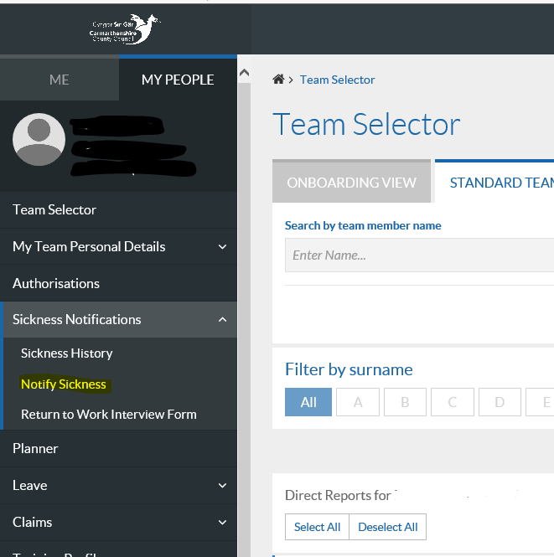

Select Sickness in Absence type
Sickness reason is Infections, Colds and flu
Sickness category is Coronavirus (self-isolation advised NHS 111)
Normal self-certification rules have been relaxed in relation to Coronavirus. Self-certification can be accepted for the period of isolation advised by NHS 111 or other NHS professional.
Input dates of sickness absence as advised by NHS 111 or other NHS health professional

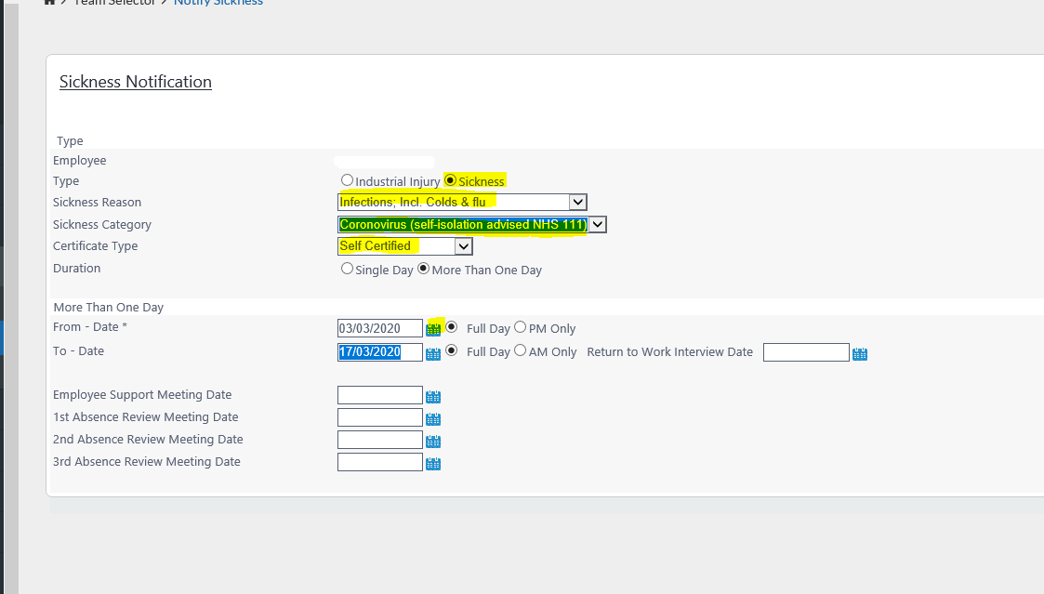

Coronavirus (diagnosed) - set up under Sickness Infections inc Cold/Flu – where an employee does have symptoms and these have been diagnosed, and has been advised by NHS Direct or an NHS health professional to self-isolate.

Select your team member and click on sickness notifications:

Select Notify Sickness:

Select Sickness in Absence type
Sickness reason is Infections, Colds and flu
Sickness category is Coronavirus (diagnosed)
Normal self-certification rules have been relaxed in relation to Coronavirus. Self-certification can be accepted for the period of isolation advised by NHS 111 or other NHS professional.
Input dates of sickness absence as advised by NHS 111 or other NHS health professional

