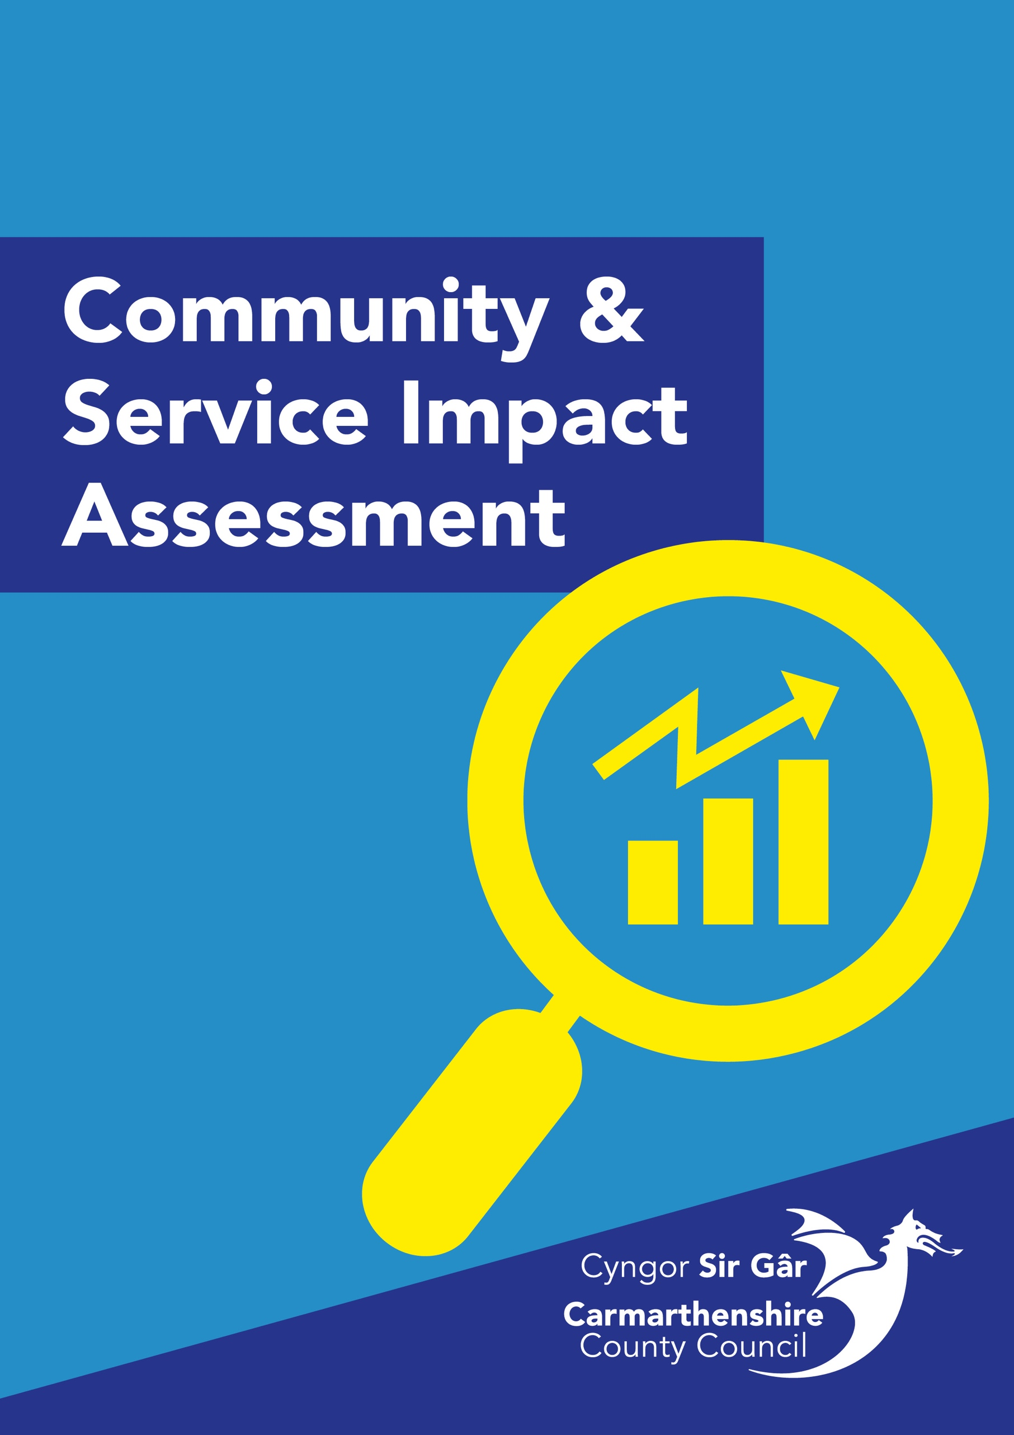

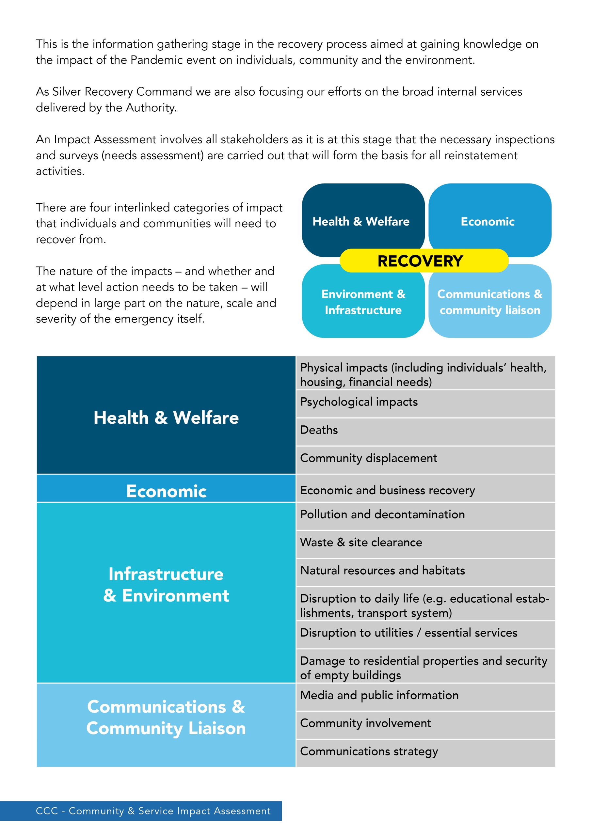

Community & Service Impact Assessment Template

Incident | COVID-19 Pandemic
Authority | Carmarthenshire County Council
Department
Service
Service Manager
Recovery Sub-Group
Date and Time of Assessment

Impact of Incident on Local Infrastructure from perspective of Authority
Community
Economy
Environment & Infrastructure
Health & Welfare

Impact of Incident From Community Perspective
Community
Economy
Environment & Infrastructure
Health & Welfare

High Level Summary Impact on Service:
Workforce Impact on Service:
Financial Impact on Service:
Potential Risk to Service:

