Employee Wellbeing Talking Toolkit
This toolkit can be used as a guide for managers during one-to-one meetings with employees to ensure their wellbeing is being considered and to identify any possible concerns. Managers should use the responses of employees to assess whether any further action is required.
This document can be used in conjunction with the below Employee Wellbeing Flowchart which will assist with further steps where required.

Example Questions
The following questions can be incorporated into your typical conversations with employees.
- How are things with you?
- How are things outside of work? (Is there anything that might be affecting your ability to work effectively?)
- How would you describe your current wellbeing?
- What steps could you take to improve your wellbeing?
- What additional support would you benefit from to help take these steps?
- Do you feel that your job is impacting on your wellbeing?
- How is your current working environment?
- Are there any barriers within your personal or working life hindering your ability to maintain or improve your general health and wellbeing?
If your employee is now working from home/remotely, you can also include some more specific questions on how this new way of working might be impacting upon their wellbeing. For example:
- How are you finding the new ways of working?
- How do you feel that working remotely is impacting on your wellbeing?
- What additional support do you feel you need to help to maintain your wellbeing whilst working from home?
- Do you feel that you have the necessary equipment to comfortably work from home?

Tips/Prompts
- Try to ask open questions to allow the employee to provide more full and informative answers.
- Where an employee raises a particular wellbeing concern; listen openly, try not to jump straight to solutions and allow the employee to make suggestions.
- Be guided by the employee’s responses. It might be that there are happy and well in which case some questions might not be so appropriate.
- Follow up with employees whether they have expressed concerns or whether they appear to be healthy and well. Things can change so it’s important to continue asking these questions overtime.

Employee Wellbeing Flow Chart
Use this as a guide for how to manage health & wellbeing issues identified by staff, only following the steps that apply to their situation. Where there is a health & wellbeing issue identified impacting your team / service, contact the Health & Wellbeing Coordinators to discuss whether and how we / Occupational Health / other areas of People Management may be able to support you.
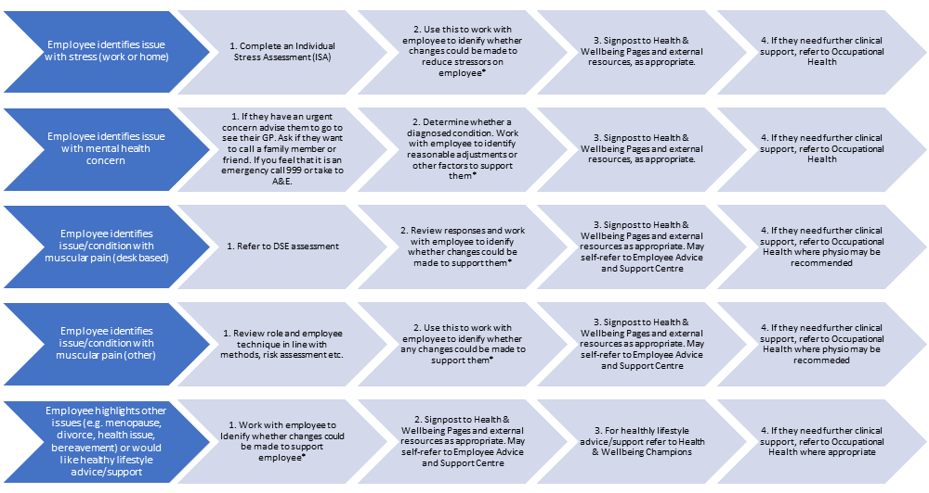
*Identify actions already being taken and therefore whether any additional actions are needed. Where any adjustments are proposed to roles, ensure these are in line with the relevant HR policies.

