Register for Multifactor Authentication
- Click on the ‘Register Here’ link provided in the email or go to https://myaccount.microsoft.com/

- Sign in with your CCC e-mail address and password.

- Select Security info from the left navigation pane and then select Add method from the Security info page.

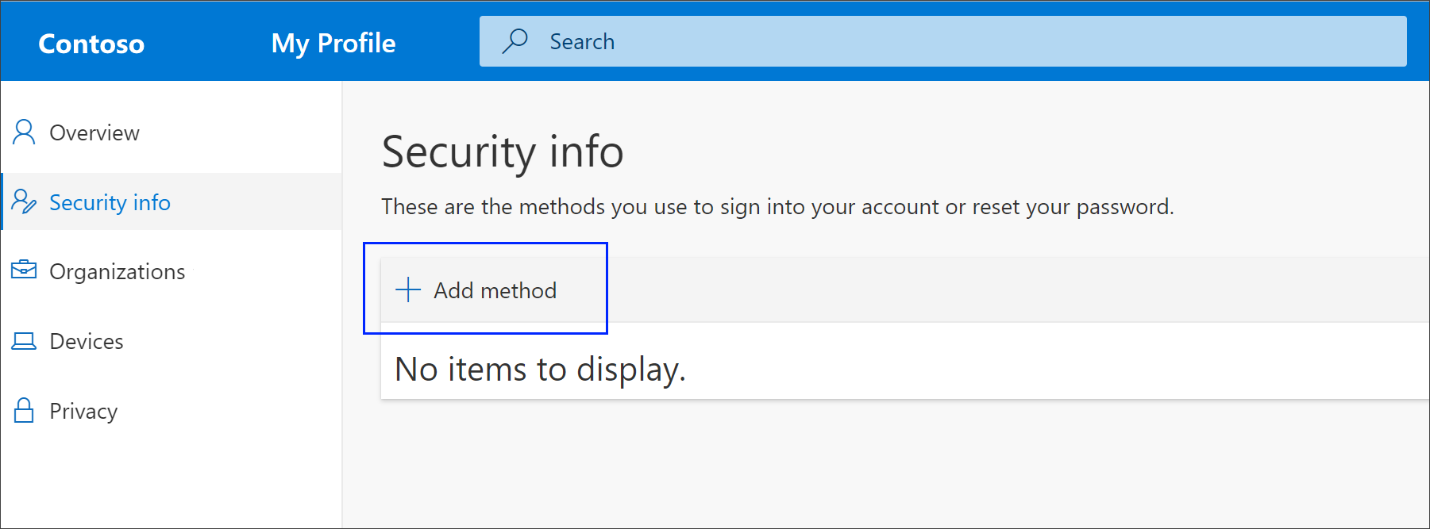
- On the Add a method page, select Authenticator app from the drop-down list, and then select Add.
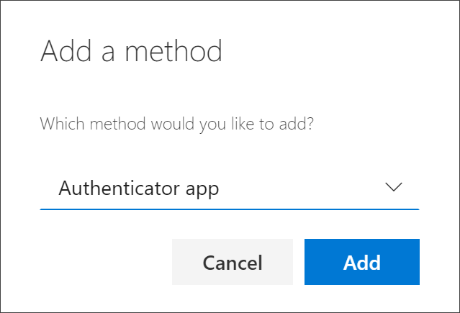
- The next page will prompt you to set up the Microsoft Authenticator app on your personal mobile device

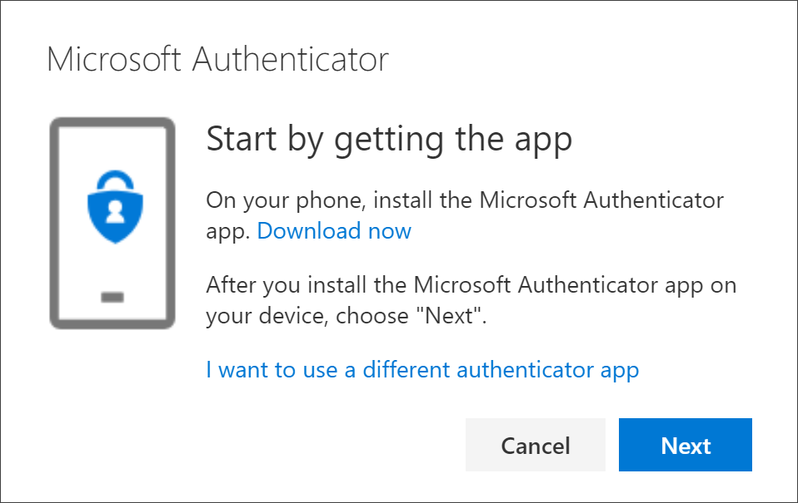

- Remain on the Set up your account page while you set up the Microsoft Authenticator app on your mobile device.

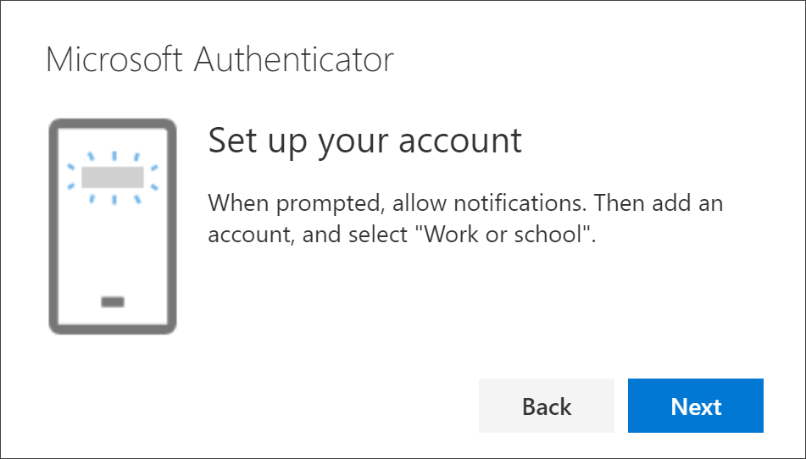

Download and install the Microsoft Authenticator app
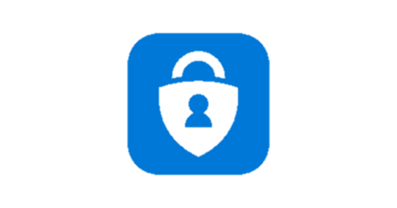
- Visit the Apple app store or Google play store on your mobile device and install the Microsoft Authenticator app. Alternatively, visit aka.ms/authapp and download the Microsoft Authenticator app.
- Once installed, open the Microsoft Authenticator app, select ‘allow notifications’ (if prompted), select Add account from the Customize and control icon (3 dots) in the upper-right corner, and then select Work or school account.
Note: If this is the first time you're setting up the Microsoft Authenticator app, you might receive a prompt asking whether to allow the app to access your camera (iOS) or to allow the app to take pictures and record video (Android). You must select Allow so the authenticator app can access your camera to take a picture of the QR code in the next step.

- Return to the Set up your account page on your computer, and then select Next. Scan the QR code page will appear.
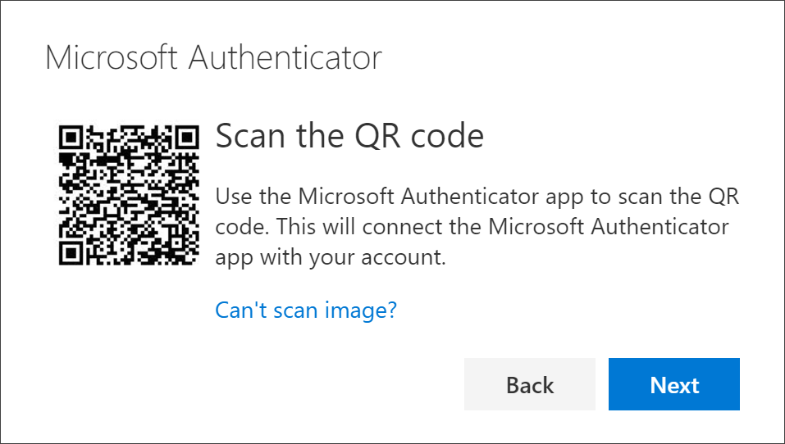
- Scan the code with the Microsoft Authenticator app QR Code reader, this should successfully add your work or school account. Select Next on the Scan the QR code page.

- A notification will be sent to the Authenticator app on your mobile device to test your account.

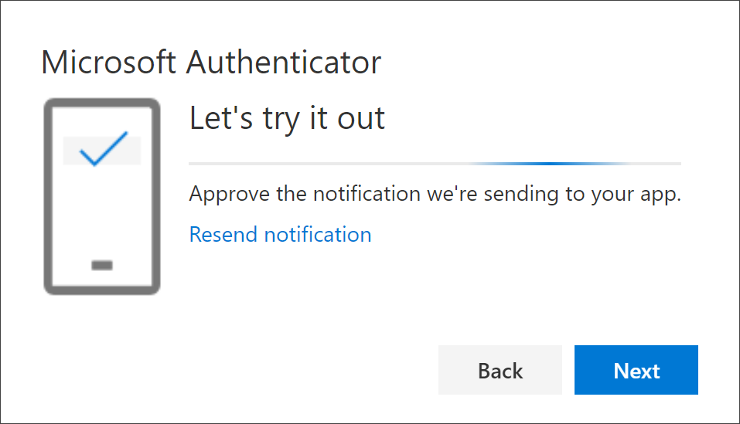
- Click ‘Approve’ on the notification in the Microsoft Authenticator app, and then select Next.
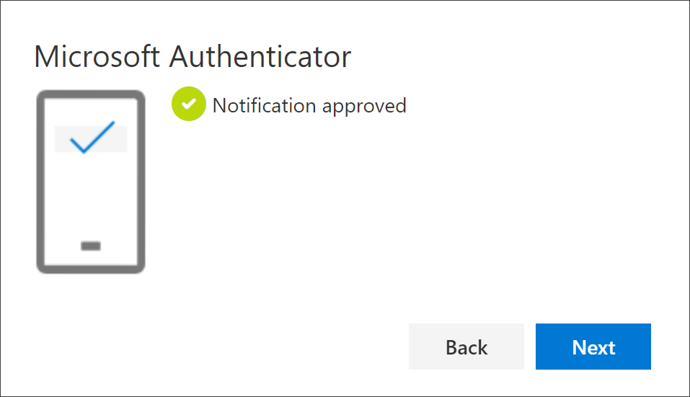
- Your security info has now been updated to use the Microsoft Authenticator app to verify your identity when using multifactor authentication.

- You will not have to do this every time you sign in. It is generally used the first time you sign into an app or device and after changing your password.

- Never approve an authentication request from Microsoft Authenticator if you have not been attempting to login to a Microsoft Resource. Do not approve or accept any request for authentication if you did not do something to trigger that request.

- If you do receive an unexpected notification, select Deny which will stop the access request. If you receive further unexpected notifications select Deny and then Dismiss. You must change your password immediately and notify IT Security via the IT Self Service Portal: https://ictselfservice.carmarthenshire.gov.wales

- If you accidently approve a notification you must change your password immediately and notify IT Security via the IT Self Service Portal as above.

