IPHONE set up
Setting up an Apple iPhone for Corporate Use

Contents

Stage 1 – Initial Set up 3
Step 1 – Hello 3
Step 2 – Select Your Country or Region 3
Step 3 – Quick Start 4
Step 4 – Choose a Wi-Fi Network 4
Step 5 – Remote Management 5
Step 6 – Location Services 5
Step 7 – Welcome to iPhone 6
Stage 2 – Setting up Company Portal 7
Step 1 – Finding the Company Portal 7
Step 2 – Sign in 7
Step 3 – Email 8
Step 4 – Password 8
Step 5 – Enable Notifications 9
Step 6 – Set up CCC access 9
Step 7 – You’re all set! 10
Step 8 – Additional Apps 10
Step 9 – Set a Passcode 11
Installing Additional Apps 12
Step 1 – Opening the Company Portal 12
Step 2 – Company Portal Apps Tab 12
Step 3 – Locating an App to Install 13
Step 4 – Install Application 13
Step 5 – Pending Install 14
Step 6 – Check the home screen 14
Accessing the intranet 15
Step 1 – Open the F5 Access app 15
Step 2 – Agree to F5’s Terms and Conditions 15
Step 3 – Allow F5 Notifications 16
Step 4 – Verify Configuration 16
Step 5 – Access the intranet 17

Stage 1 – Initial Set up

Firstly, ensure the device is charged. Once powered on (you may need to hold the single power button on the right side of the iPhone for a few seconds) you will be greeted with the message shown in Step 1.

Step 1 – Hello

To begin, press the home button as prompted at the bottom of the screen to begin the setup.

The home button is the circular button located towards the bottom of the device.

Step 2 – Select Your Country or Region

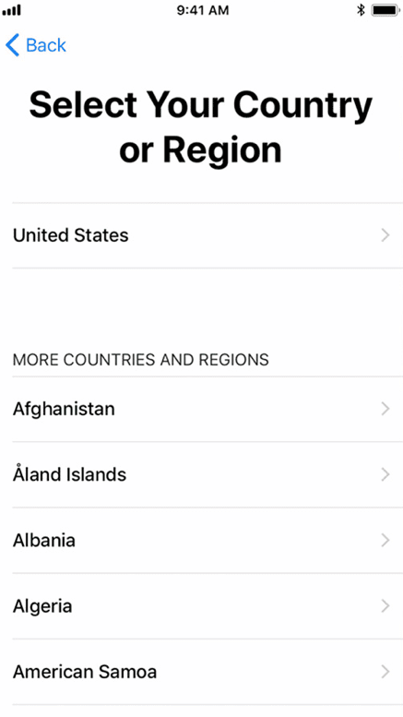 | On the next screen you will be prompted to select a language.  Then you will be asked to select your country/region.  Search for the United Kingdom and tap it.

Step 3 – Quick Start

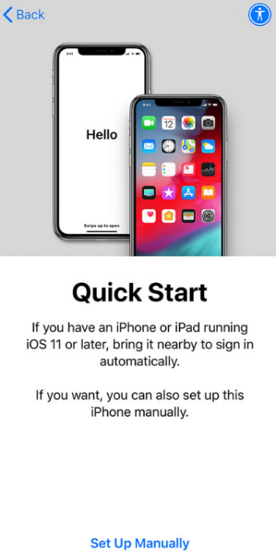 | On the next screen you will be prompted to Quick Start. Simply tap the blue text titled “Set Up Manually” to advance.

Step 4 – Choose a Wi-Fi Network

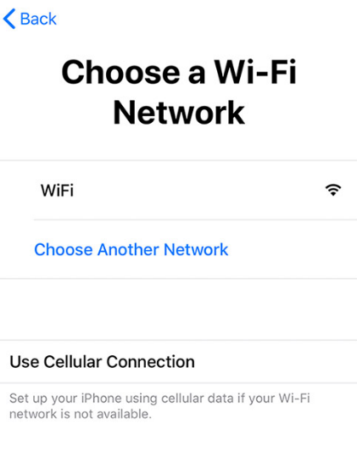 | You will now be connecting the iPhone to the internet. From the listed networks, search for your Wi-Fi Network name (this name can usually be found on the back of your internet hub) and tap it.  You will be prompted to enter your Wi-Fi password, if you have not already set a new Wi-Fi password then this should also be located on the back of your internet hub.  Once successfully connected, you will see a blue checkmark, then tap the Next button in the top right.

Step 5 – Remote Management

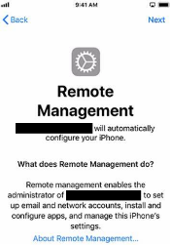 | You will now be shown the Remote Management screen, which will set up the device for corporate use.  Tap the Next button in the top right corner of the screen to advance.

Step 6 – Location Services

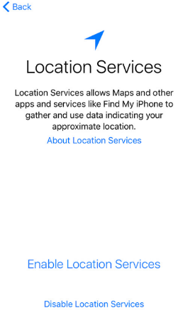 | Once the corporate profile has been installed you will be shown Location Services.  Enable or Disable Location Services based on your preference (please note that some apps may not function correctly without enabling Location Services).

Step 7 – Welcome to iPhone

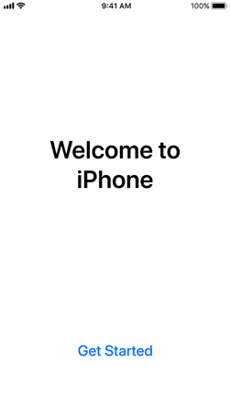 | You have successfully completed the initial setup of the iPhone.  Please tap Get Started towards the bottom of the screen to begin using the iPhone.

Stage 2 – Setting up Company Portal

It is important to set up Company Portal on your device. This will set up your device so that you can access your Corporate Emails, files etc.

Step 1 – Finding the Company Portal

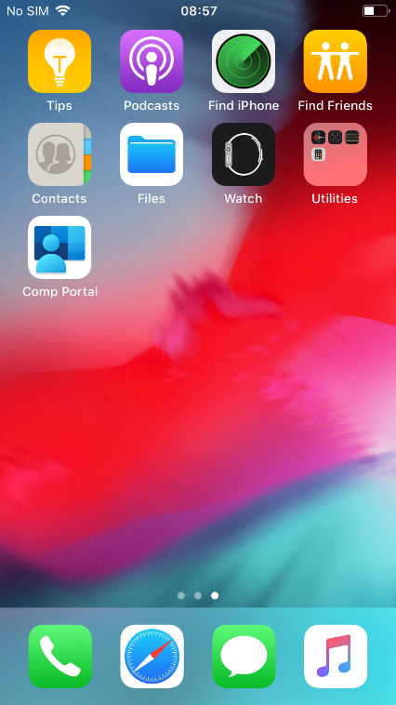 | From the home screen swipe the screen from right to left to see additional apps.  Please tap Comp Portal. (This may take some time to install and appear on the home screen.)

Step 2 – Sign in

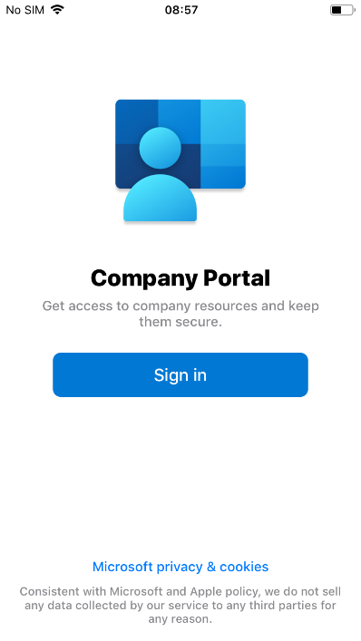 | The screen on the left will appear, tap the blue Sign in button.

Step 3 – Email

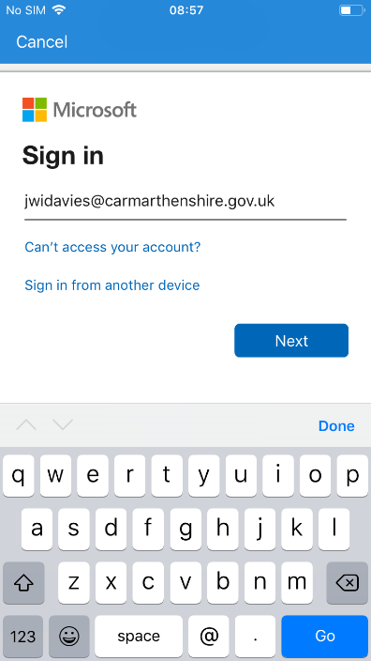 | You will now be asked to sign into your Microsoft account. Enter your corporate email address into the box.  Your corporate email address is your corporate username@carmarthenshire.gov.uk

Step 4 – Password

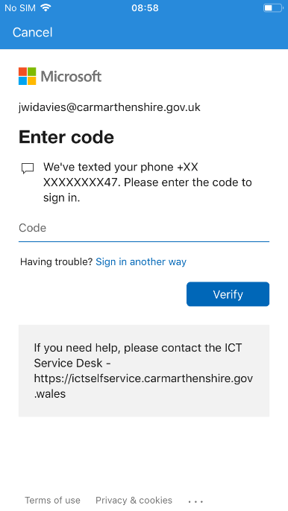 | You will then be asked to enter your corporate password (the one you use to log into your laptop every day).  Please note that you may see the left screen instead. This asks for a code which was sent to your mobile device.  Once logged in, please wait a moment, and move onto the next step.

Step 5 – Enable Notifications

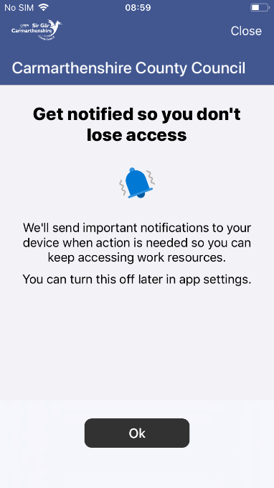 | On the next screen tap OK and then select Allow access if you would like Company Portal to send your mobile device important notifications.

Step 6 – Set up CCC access

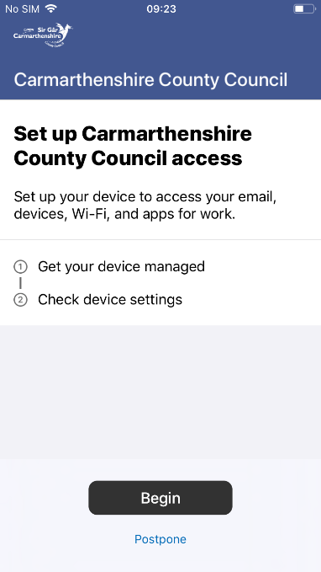 | Now tap the Begin button which will set up the device with your corporate account.  This process may take a few minutes.

Step 7 – You’re all set!

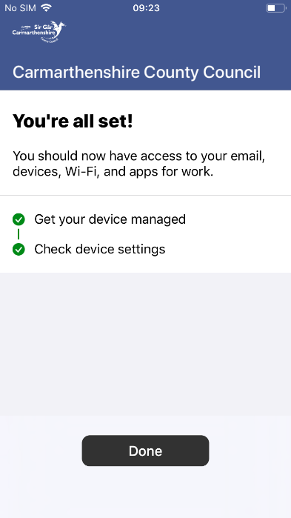 | Once you receive the message shown on the left, your device will be ready to go.  Tap the Done button below to finish the setup of Company Portal.  Return to the home screen, by pressing the iPhone home button.

Step 8 – Additional Apps

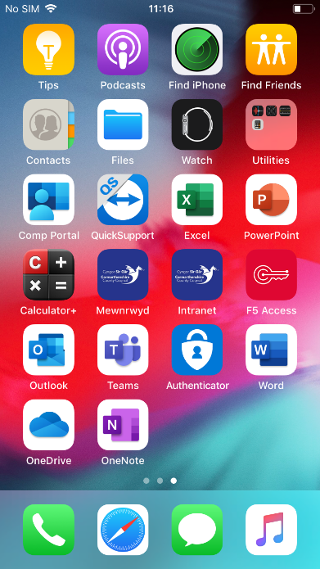 | After a couple of minutes, additional apps should begin installing and show on your home screen as seen in the left screenshot.

Step 9 – Set a Passcode

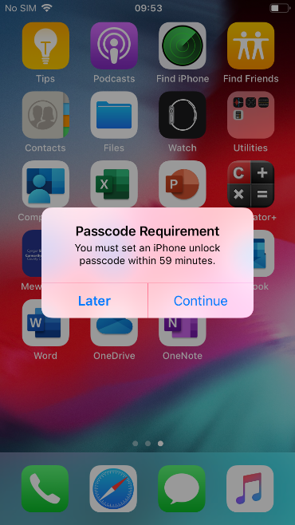 | At any stage after setting up the Company Portal, you should receive the message shown on the left screen, asking you to set up a passcode.  Tap Continue to set up the passcode.  This passcode is a number that you will need to enter each time the device goes to sleep. This prevents unauthorised access to the device.

Installing Additional Apps

It is possible to download additional apps on to your iPhone, these apps have been approved for Corporate usage. In addition, apps will be updated/added to the company portal that will become available to you, so it is worth checking it regularly for new apps.

Step 1 – Opening the Company Portal

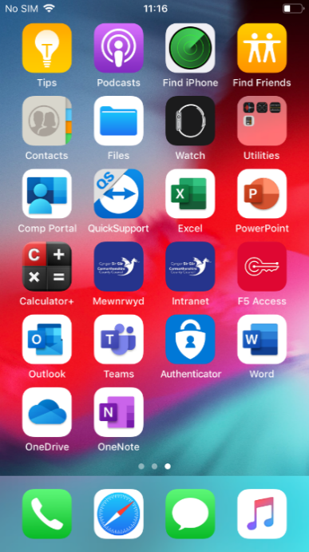 | From the home screen swipe the screen from right to left to see additional apps.  Please tap Comp Portal.

Step 2 – Company Portal Apps Tab

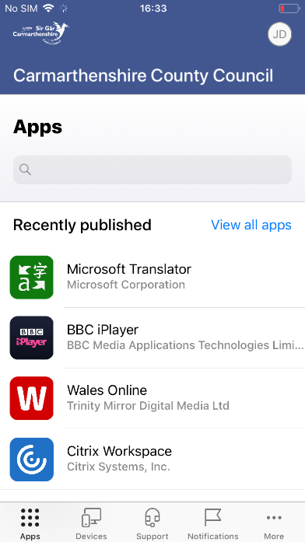 | Ensure the Apps tab is selected at the bottom and tap the blue text titled View all apps.

Step 3 – Locating an App to Install

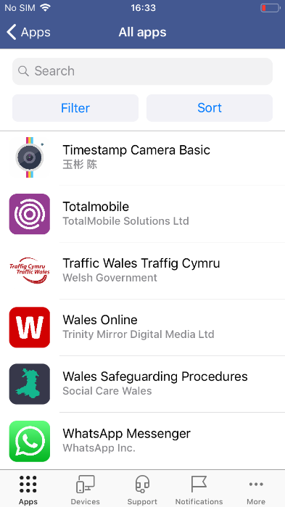 | You will see a list of apps that you can install for free.  Tap an app that you would like to install. (You can use the Search bar/Filter/Sort options at the top of the screen to narrow down the results that appear)

Step 4 – Install Application

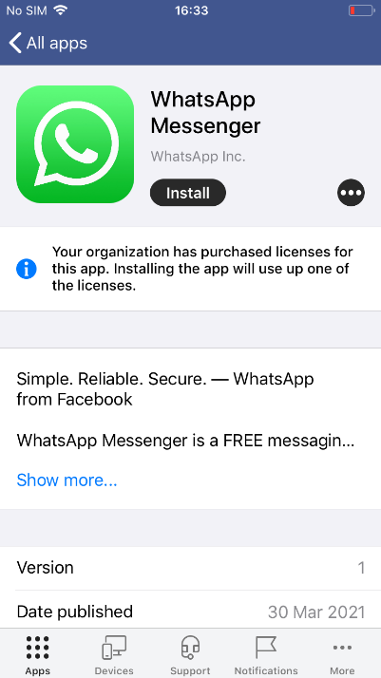 | Tap the Install button to begin installing the app.

Step 5 – Pending Install

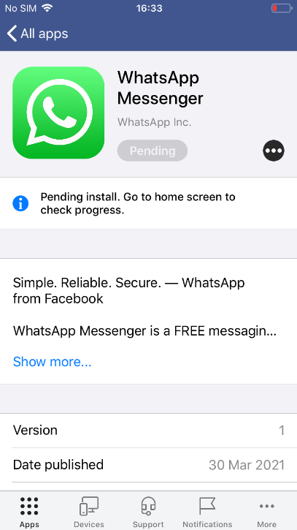 | The app will be Pending and then eventually begin installing.  Press the home button to return to the iPhone home screen.  Depending on your network speed this step may take some time.

Step 6 – Check the home screen

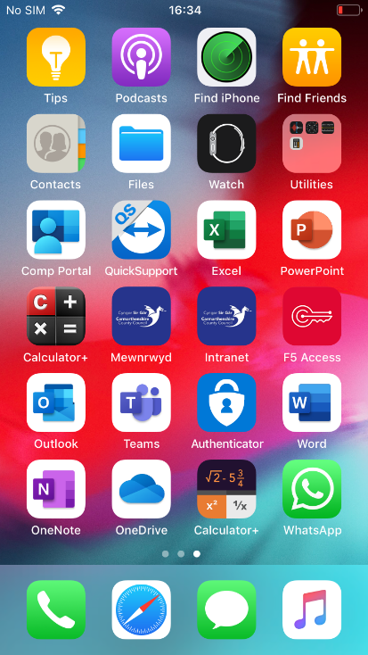 | You can view the app install progress from the iPhone home screen.  The example on the left shows that the app has installed successfully.

Accessing the intranet

To use the intranet app located on your iPhone home screen, you will need to set up the F5 Access app.

Step 1 – Open the F5 Access app

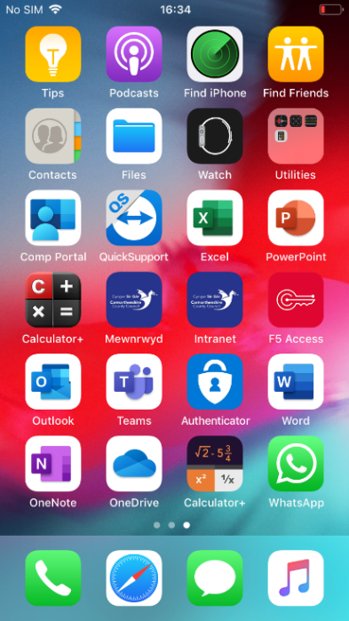 | Tap the app icon called F5 Access as seen in the left screenshot.

Step 2 – Agree to F5’s Terms and Conditions

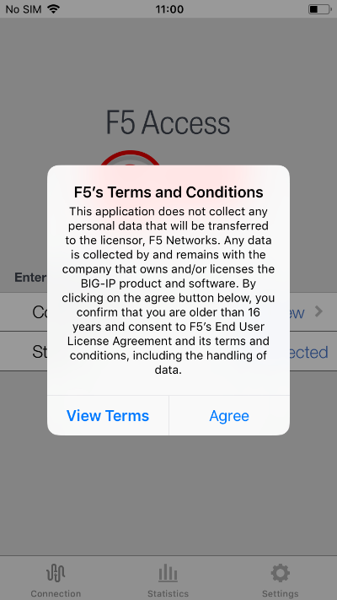 | You will be prompted to read F5’s Terms and Conditions. Please read the Terms and Conditions, and if you agree tap Agree.  You must tap Agree to use the app.

Step 3 – Allow F5 Notifications

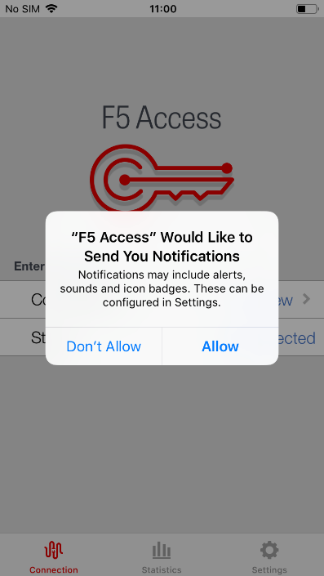 | Tap Allow/Don’t Allow based on your preference for notifications from F5 Access.

Step 4 – Verify Configuration

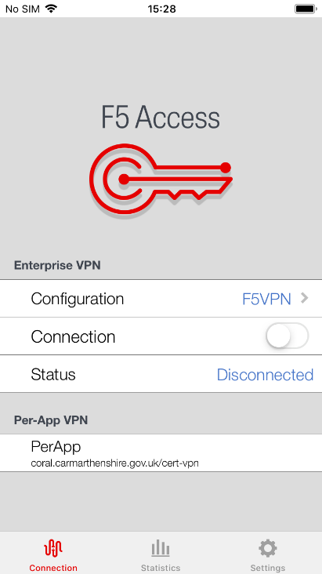 | Now verify that besides Configuration, F5VPN is show as seen in the screenshot on the left.  (This step may take some to apply, you may continue to use the device during this time.)

Step 5 – Access the intranet

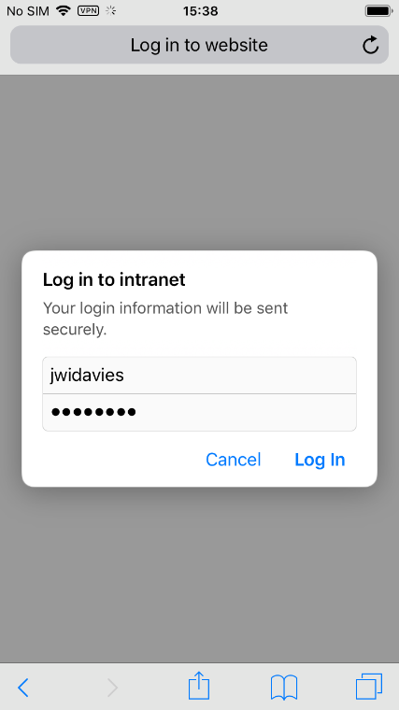  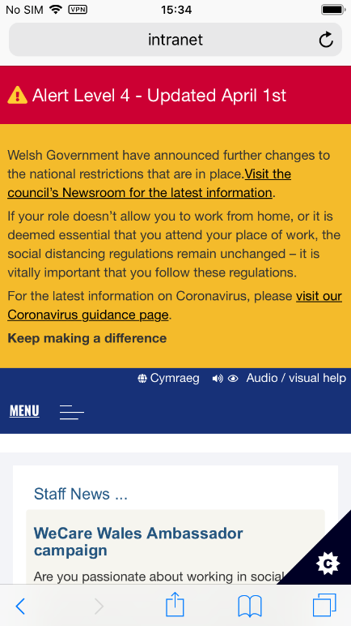 | Return to the home screen and tap intranet.  The F5 Access VPN will connect whilst you are using the intranet, and you will be prompted to log in to the intranet using your corporate username and password.

