Date of report: | 11 January 2024
Approved by: | Corporate Health and Safety Leadership Board
Reference:  Review Due: | CEX-FA-001  January 2027
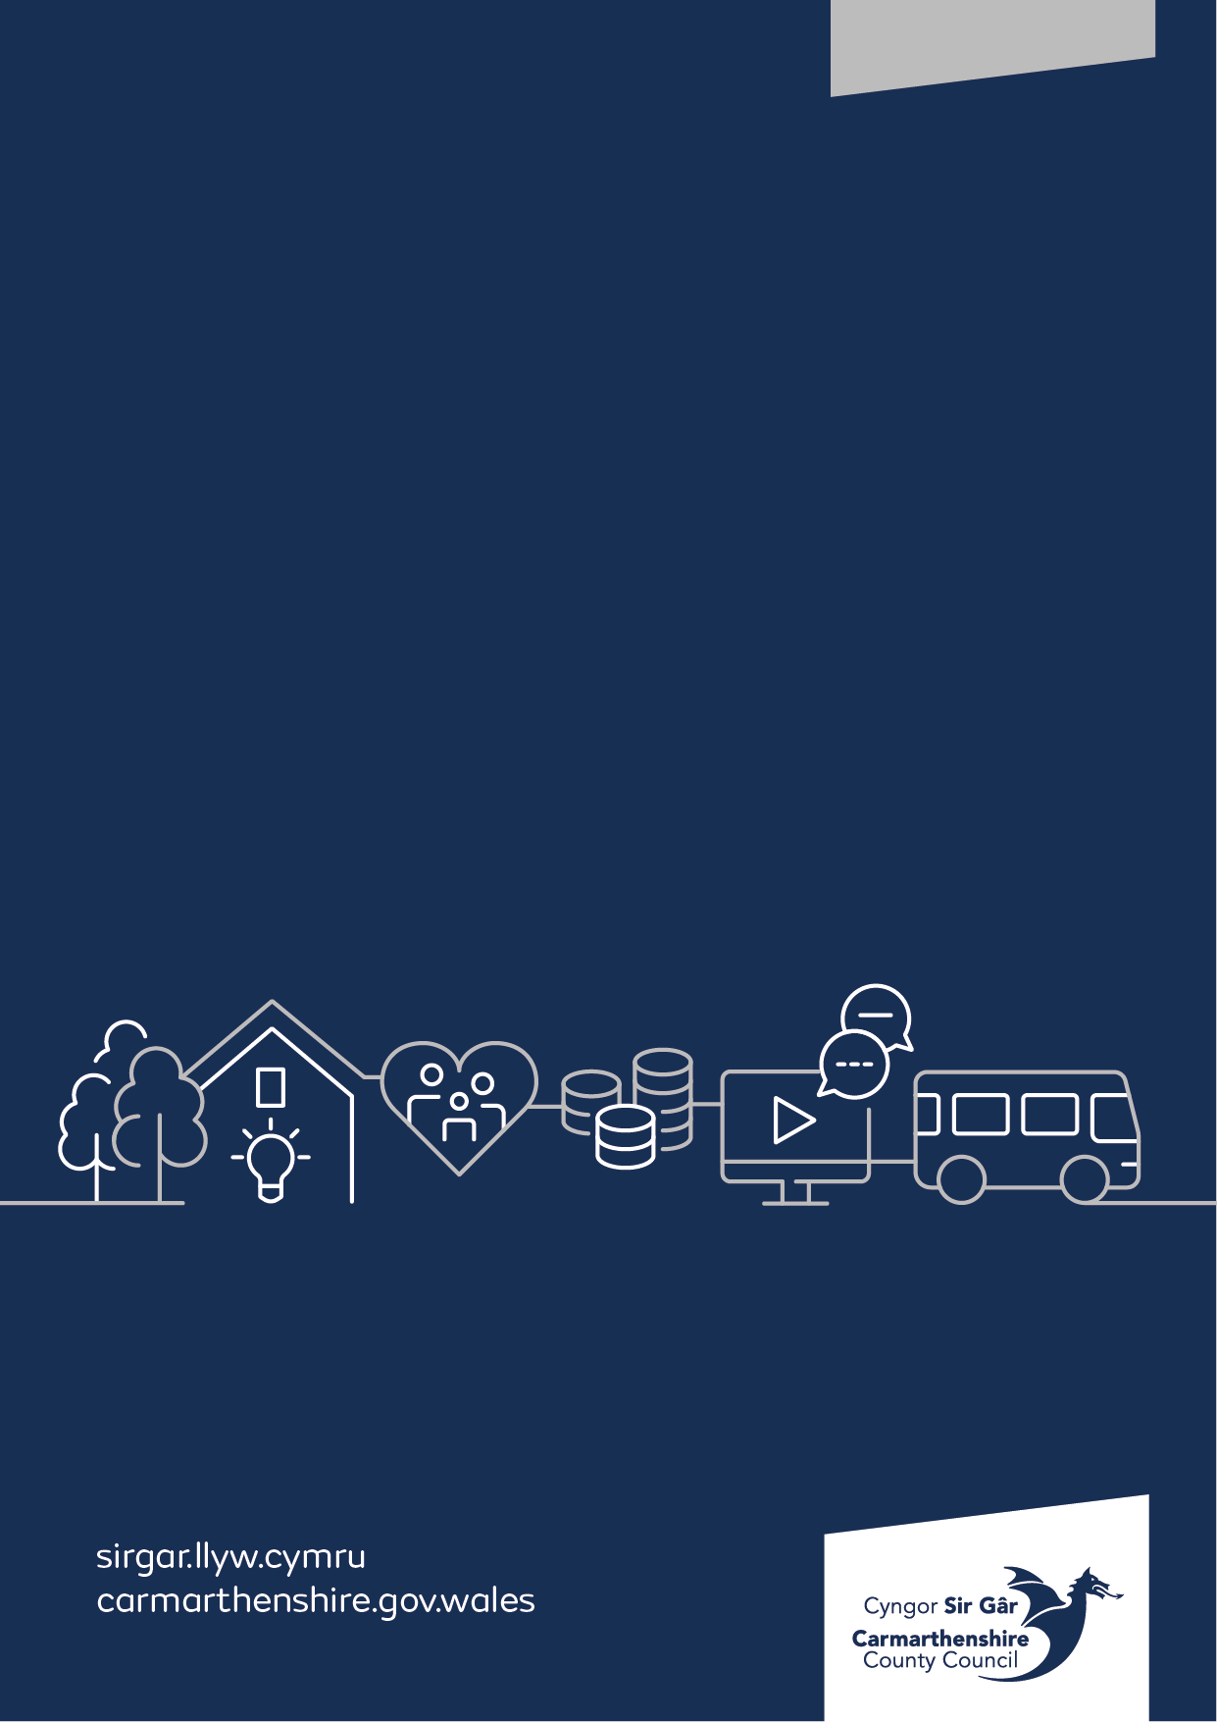
Health Safety & Wellbeing

First Aid Needs Assessment

 | Subject | Page/s
1.0 | Introduction | 2
2.0 | Scope | 2
3.0 | Types of First Aid Training | 2-3
4.0 | First Aid Needs Assessment | 3-4
5.0 | Conclusion | 4
 | Appendix 1 | 5-10

- Introduction
Carmarthenshire County Council is required by the Health and Safety at Work etc. Act 1974 and the Health and Safety (First Aid) Regulations 1981 to provide adequate and appropriate equipment, facilities, and personnel to ensure employees receive immediate attention if they are injured or taken ill at work.
In addition, the authority has a moral duty to take into consideration the first aid requirements for those who are not employed, e.g., members of public, service users, pupils etc.
The previous first aid needs assessment was undertaken several years ago. This required a review, and this is the purpose of providing this report.
Therefore, it is essential that the previous first aid needs assessment is reviewed and clarifies if the current position of recommended training levels remains current to meet the required duties place on the authority.
- Scope
This report covers the first aid needs assessment of the authority, schools, and services to ensure that suitable first aid training levels and training are made available.
This report does not outline specific arrangements (such as numbers of first aiders or equipment) for services, workplaces, or buildings. Each Manager / Head Teacher should identify the suitable number of appointed persons, first aiders and first aid equipment and this should be in line with the needs of the service, workplace, or building. Guidance is available on the intranet / Porth to assist in this process.
- Types of First Aid Provision
Appointed Person

The role of this appointed person includes looking after first-aid equipment and facilities and calling the emergency services when required. They can also provide emergency cover where a first aider is absent due to unforeseen circumstances (annual leave does not count). An appointed person does not need first-aid training. An appointed person is not necessary where there are an adequate number of appropriately trained first aiders.

Emergency First Aid at Work (1 day trained first aider)

The role of an Emergency First Aid at Work (EFAW) trained first aider – at this level the first aider is qualified to give emergency first aid to someone who is injured or becomes ill while at work. They are also responsible for looking after first aid equipment in their areas of work to ensure supplies are maintained and are within the recommended expiry dates.

In addition to the standard training, this type of first aider is trained in the use of a defibrillator.

For specific types of premises and roles the training provided focuses on specific areas of first aid, for example, there is a paediatric adaptation that is provided for all Primary Schools and where services are provided to children 4 years old and under etc.

Additionally, the one-day course can be adapted to include additional bolt on areas such as catastrophic bleeding for those who use higher risk equipment such as chainsaws.

Where required additional standalone workshops for specific medical condition management such as epilepsy can be provided to ensure all relevant staff, including first aiders, receive appropriate training to manage these conditions and administration of medication.

First Aid at Work (3 day trained first aider)

The role of a First Aid at Work (FAW) trained first aider – qualified to EFAW level but can also apply first aid to a range of specific injuries and illnesses. They are also responsible for looking after first aid equipment in their areas of work to ensure supplies are maintained and are within the recommended expiry dates.

This level of training covers a wider range of specific first aid treatments, usually required where a specific first aid needs assessment identifies that there is an increased risk of first aiders being required to deal with issues such as poisoning, anaphylaxis, burns or fractures.

Mental Health First Aider

The main aim of the Mental Health First Aider is to spot the signs of possible mental ill-health and to provide initial support to staff who need assistance, in much the same way as a physical First Aider responds to physical injury or illness. The Mental Health First Aider will be supported to promote a workplace culture where staff are free to discuss mental health issues openly and feel supported by their colleagues when they do so.
- First Aid Needs Assessment
In order to identify the levels of training that Carmarthenshire County Council should provide, an overarching first aid needs assessment has been undertaken. The needs assessment has considered the following:

- The type of work undertaken across the authority.
- Hazards and the likely risk of them causing harm.
- The size of the workforce, split across departments, divisions, and services.
- Work patterns, holidays and absences.
- The history of accidents within the authority.
- Access to emergency medical services.
- Provision of first aid for non-employees such as members of public, pupils and service users.

A copy of the overarching needs assessment is at appendix 1.

To identify the number of first aiders and the equipment required for each workplace, service or building, Managers / Head Teachers should undertake a specific first aid needs assessment following the First Aid Guidance on the intranet / Porth. If a department, division, or service believes that they require alternative first aid arrangements for a specific reason, it is recommended that the Manager / Head Teacher includes this in their first aid needs assessment and discuss this with the health and safety team.
- Conclusions and Recommendations
Taking into consideration the first aid needs assessment, it has confirmed that the authority position previously identified has been upheld. Therefore, the standard level of training recommended is:
- Emergency First Aid at Work (EFAW) 1 day trained first aid cover with additional elements to be identified by the service for inclusion on the course.

The only deviation from this, may be possible in lower risk environments, such as offices with limited numbers and no access by members of public, pupils, or service users. In these locations and as a temporary measure and where hybrid working is developing, Managers / Head Teachers can identify an appointed person as a minimum to provide a consistent level of cover.
The recommendation for refresher or repeat training is to ensure that all EFAW first aiders receive refresher training at a minimum of 3-year intervals, however, if the first aider requests refresher training due to inactivity during this period, this should be supported.
It is recommended that all Managers / Head Teachers undertake a review of their first aid needs assessment to clarify they currently have in place the required numbers of first aiders and provide an appropriate amount of equipment.
First Aid Guidance is available on the intranet / Porth to support Managers / Head Teachers in meeting their duty to provide first aid cover and equipment.

Appendix 1
Department / Division / Service | Type of work undertaken | Highest risk for hazards / injuries | Access to medical services | Accident history | Access by members of public, pupils, service users | Appointed Person / EFAW / FAW | Additional Elements
Place & Infrastructure  Environmental Infrastructure | Construction & Maintenance  Vehicle maintenance  Grounds maintenance  Site visits / inspections  Electrical  Engineering  Design  Work on public highway | Vehicle contact  Chainsaw injuries  Use of tools | Standard but some areas of work are remote and rural | Mostly minor injuries, occasional major | Some contact | EFAW | Catastrophic Bleeding for chainsaw use  Some bespoke areas for medication (e.g., passenger transport)
Place & Infrastructure  Environmental Infrastructure | Waste collection  Grounds maintenance  Site visits and inspections  Work on public highway | Vehicle contact  Chainsaw injuries | Standard but some areas of work are remote and rural | Mostly minor injuries, occasional major | Some contact | EFAW | Catastrophic Bleeding for chainsaw use
Place & Infrastructure  Place & Infrastructure | Site visits and inspections  Work on public highway | Vehicle contact  Slips, trips, falls | Standard but some areas of work are remote and rural | Minor injuries | Regular contact | Appointed person minimum cover but recommend EFAW | N/A
Place & Infrastructure  Property | Tool use  Maintenance  Site visits | Vehicle contact  Slips, trips, falls Use of tools | Standard but some areas of work are remote and rural | Mostly minor injuries, occasional major | Regular contact | EFAW | N/A
Place & Infrastructure  Business Support & Improvements | Office based activities  Cleaning services | Use of cleaning materials  Manual handling | Standard but some areas of work are remote and rural | Minor injuries | Some contact | Appointed person minimum cover but recommend EFAW | N/A
Communities  Homes & Safer Communities | Social care work  Visits to domestic properties  Housing – office & community support  Site visits | Manual handling  Medication  Slips, trips, falls  Violence & Aggression | Standard but some areas of work are remote and rural | Mostly minor injuries, occasional major | High level of contact | EFAW | Some bespoke areas for medication

Communities  Adult Social Care | Social care work  Social work activities  Visits to domestic properties  Site visits  Office based activities | Manual handling  Medication  Slips, trips, falls  Violence & Aggression | Standard but some areas of work are remote and rural | Mostly minor injuries, occasional major | High level of contact | EFAW | Some bespoke areas for medication
Communities  Integrated Services | Social care work  Social work activities  Visits to domestic properties  Site visits  Office based activities | Manual handling  Medication  Slips, trips, falls  Violence & Aggression | Standard but some areas of work are remote and rural | Mostly minor injuries, occasional major | High level of contact | EFAW | Some bespoke areas for medication
Communities  Leisure & Sport | Leisure centre provision  Community leisure activities  Country Parks including grounds maintenance activities  Cultural premises  Events  Catering | Manual handling  Slips, trips, falls  Violence and Aggression  Vehicle contact  Chainsaw injuries | Standard but some areas of work are remote and rural | Mostly minor injuries, occasional major | High level of contact | EFAW | Catastrophic Bleeding for chainsaw use

Education & Children  Schools | Educational based activities  Sporting activities  Special Educational Needs  Supporting children with medical needs  Grounds maintenance  General maintenance | Manual handling  Slips, trips, falls  Violence and Aggression  Vehicle contact  Use of tools  Medical | Standard but some areas of work are remote and rural | Mostly minor injuries, occasional major | High level of contact | EFAW (Paediatric) | Some bespoke areas for medication
Education & Children  Children’s Services | Social work activities  Fostering  Youth work  Care services | Manual handling  Medication  Slips, trips, falls  Violence & Aggression | Standard but some areas of work are remote and rural | Mostly minor injuries, occasional major | High level of contact | EFAW (Paediatric) | Some bespoke areas for medication
Education & Children  Access to Education | Office based activities  Catering activities  Site visits  Meeting with parents / public | Manual handling  Slips, trips, falls  Violence and Aggression  Use of catering tools & equipment | Standard but some areas of work are remote and rural | Mostly minor injuries, occasional major | High level of contact | EFAW | N/A

Education & Children  Curriculum & Wellbeing | Office based activities  Site visits  Meeting with parents / public | Manual handling  Slips, trips, falls  Violence and Aggression  Medical | Standard but some areas of work are remote and rural | Minor injuries | Regular contact | EFAW | N/A
Education & Children  Education & Inclusion | Office based activities  Site visits  Meeting with parents / public | Manual handling  Slips, trips, falls  Violence and Aggression  Medical | Standard but some areas of work are remote and rural | Minor injuries | Regular contact | EFAW | N/A
Education & Children  Primary Schools | Office based activities  Catering activities  Provision of Education to children aged 3-11 years.  Meeting with parents / public | Manual handling  Slips, trips, falls  Violence and Aggression  Use of catering tools & equipment  Medical | Standard but some schools are remote and rural | Mostly minor injuries, occasional major | High level of contact | EFAW (Paediatric) | Some bespoke areas for medication
Education & Children  Secondary Schools | Office based activities  Catering activities  Provision of Education to children and young adults from 11-18 years old.  Meeting with parents / public | Manual handling  Slips, trips, falls  Violence and Aggression  Use of catering tools & equipment  Medical | Standard but some schools are remote and rural | Mostly minor injuries, occasional major | High level of contact | EFAW | Some bespoke areas for medication
Education & Children  Special Educational Needs Schools / Behavioural Units | Office based activities  Catering activities  Provision of Education to children and young adults with special educational needs or behavioural related needs.  Meeting with parents / public | Manual handling  Slips, trips, falls  Violence and Aggression  Use of catering tools & equipment  Medical | Standard but some schools are remote and rural | Mostly minor injuries, occasional major | High level of contact | EFAW  EFAW (Paediatric) | Some bespoke areas for medication
Chief Executives  All Divisions | Town / Markets  Marketing & Media  ICT  Electoral Services  Regeneration  Office based activities | Manual handling  Slips, trips, falls  Violence and Aggression | Standard but some areas of work are remote and rural | Minor injuries | Regular contact | EFAW | N/A
Corporate Services  All Divisions | Office based activities  Financial services  Cash desks  Audit & Risk Management services | Manual handling  Slips, trips, falls  Violence and Aggression | Standard but some areas of work are remote and rural | Minor injuries | Regular contact | EFAW | N/A

